1. Design an ERD for an airline reservation system. The system should include entities like passengers, flights, tickets, and airports. Passengers can book multiple tickets, and each ticket is associated with one passenger. Flights depart from and arrive at specific airports.

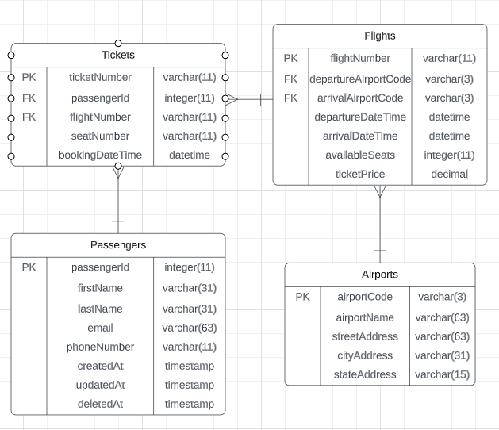

Airports Table:

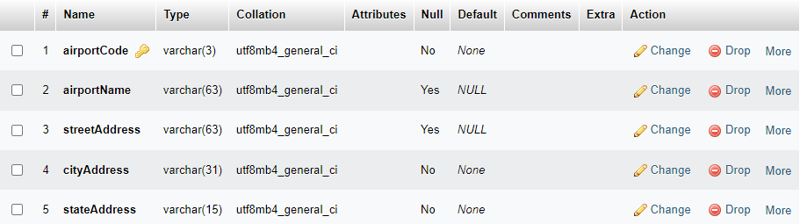

Flights Table:

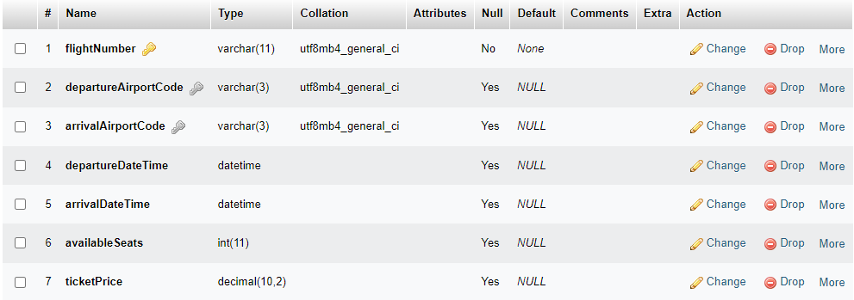

Passengers Table:

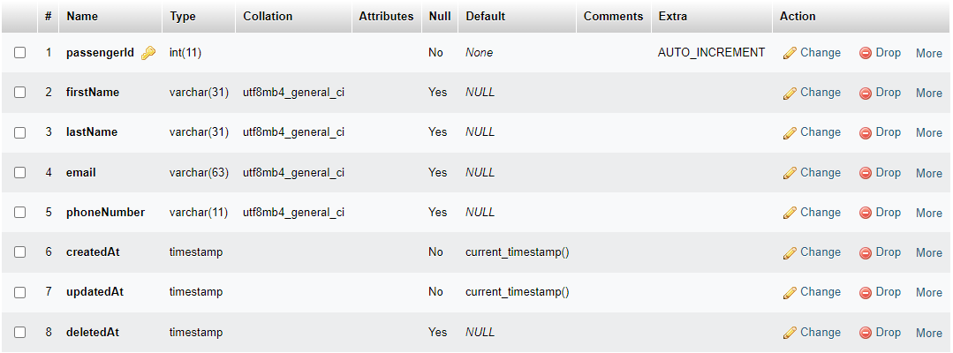

Tickets Table:

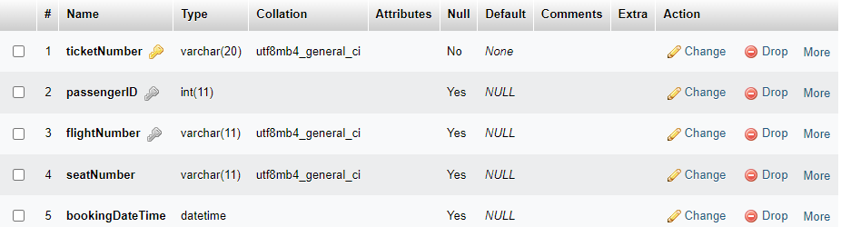

2. Design an ERD for an employee management system for a company. Entities should include employees, departments, projects, and supervisors. Show how employees are assigned to departments and projects.

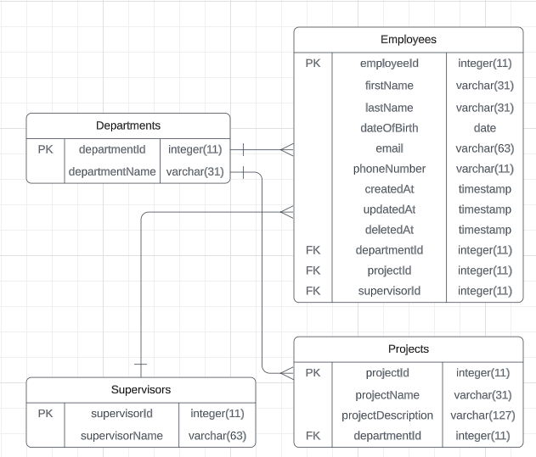

Departments Table:

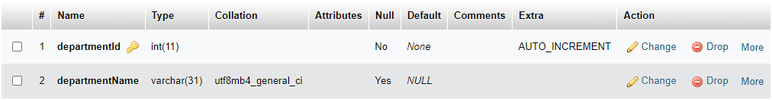

Employees Table:

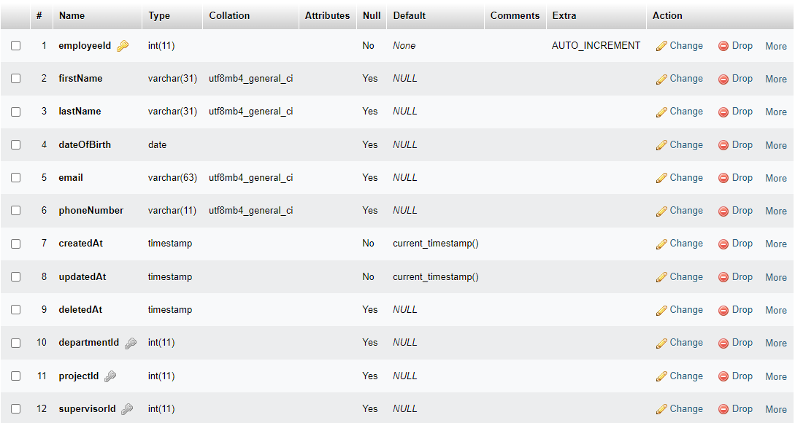

Projects Table:

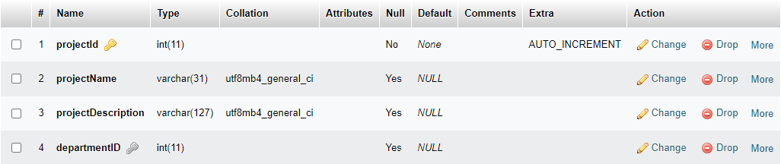

Supervisors Table:

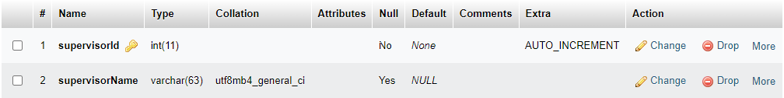

3. Create an ERD for an online blogging platform. Entities should include bloggers, articles, comments, and categories. Show how bloggers can write articles, readers can comment on articles, and articles can be categorized.

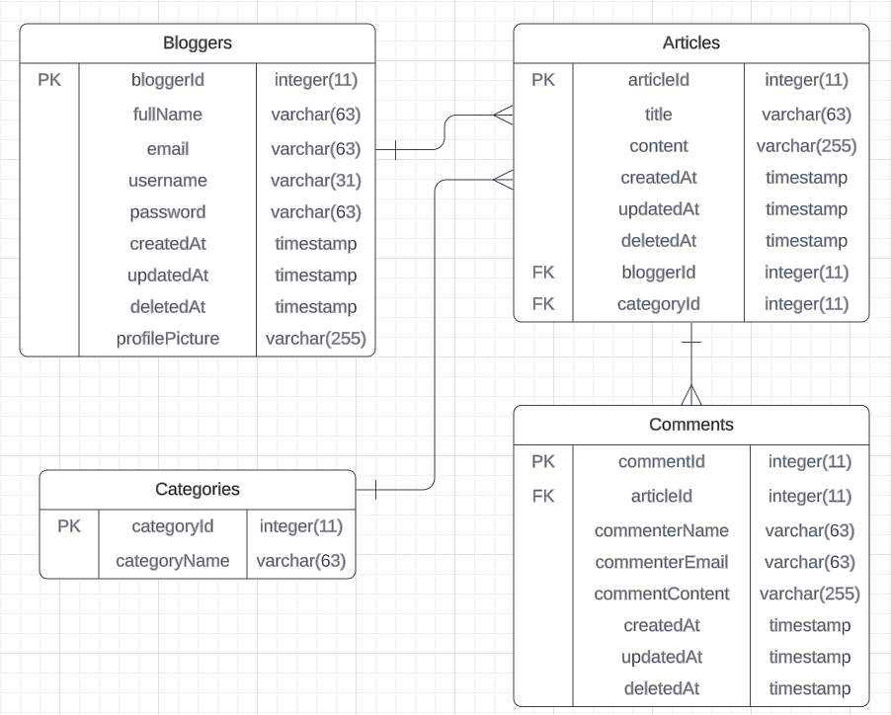

Articles Table:

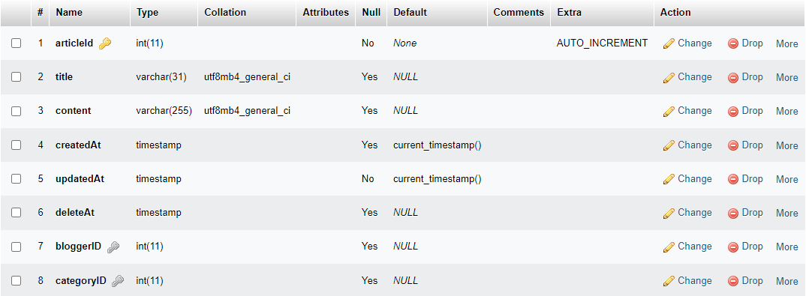

Bloggers Table:

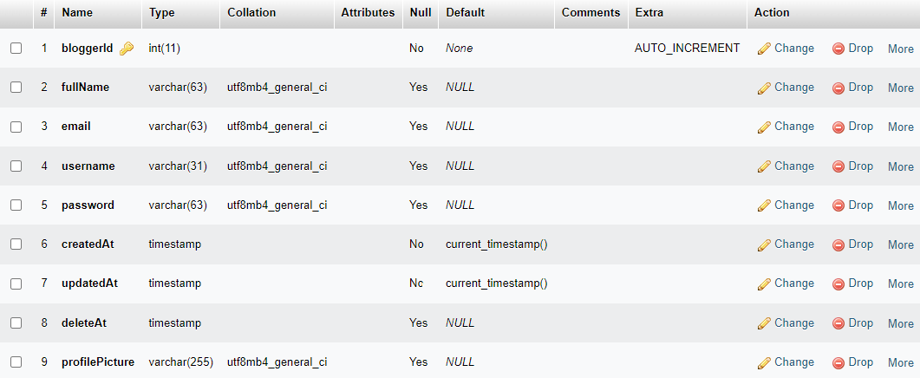

Categories Table:

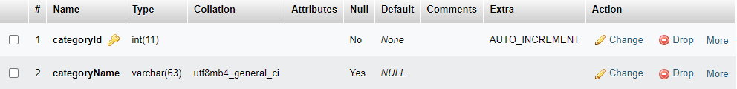

Comments Table:

